Quiz 1

Jeremy Scheuerman

250

1. 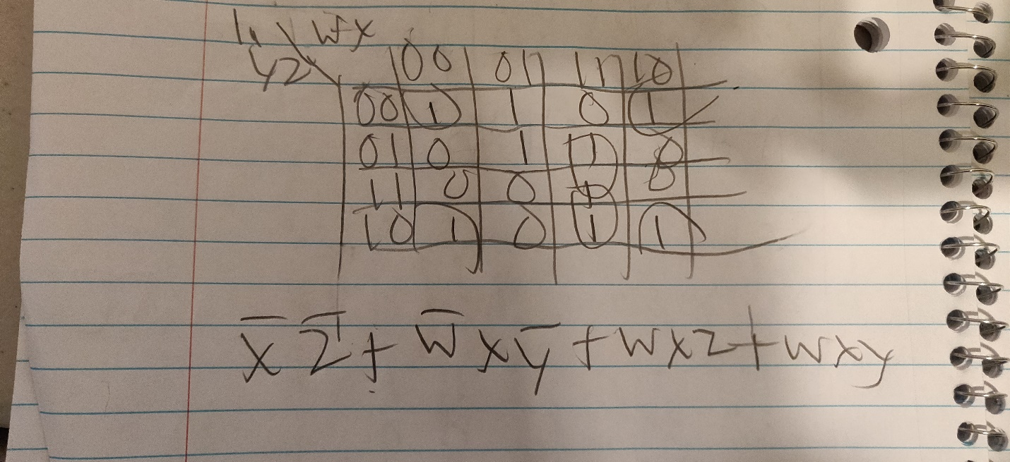
2. 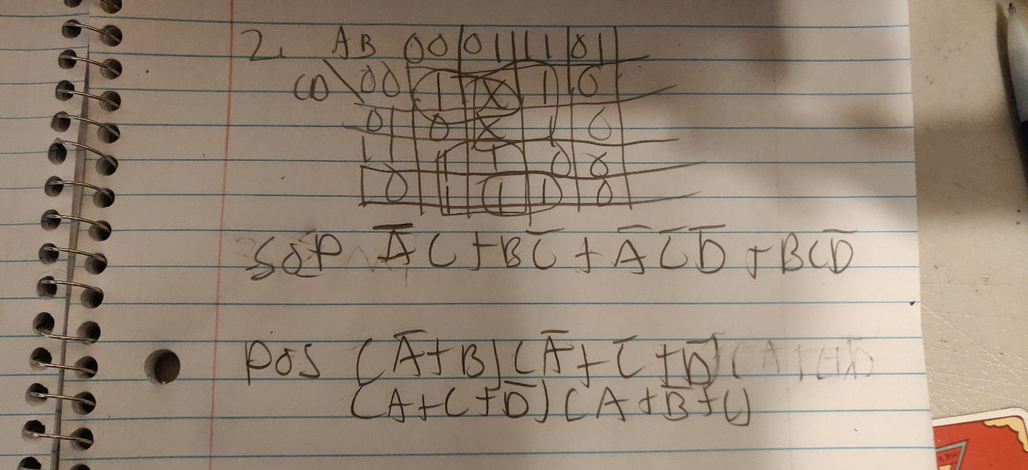
3. 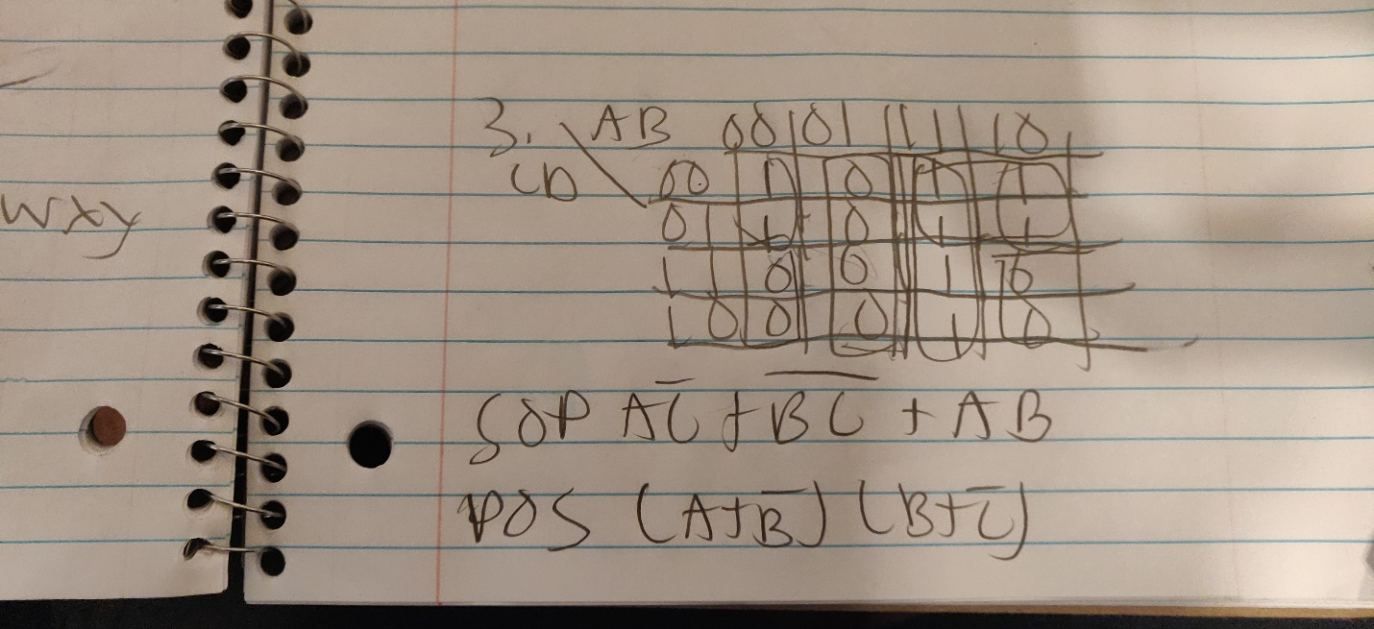

Sorry I have handwriting disorder I tried to make it as legible as I could